Bernard Owusu Sefah & Brandon Kowal

LAB REPORT 6: LAWN SPRINKLER SYSTEM

Abstract

The lab is a simplified lawn sprinkler system. This will help us design two-level all-NAND combinational logic circuit prototyping. The circuit has 5 inputs one of them to tell if the external timer device is on or off. The other 4 inputs are sensors for the rain, humidity, soil salinity, and soil moisture. There are 5 outputs and one of the outputs is to tell if the systems is running or not the other 4 are to display if the standby or on with a S and O or 5 and 0.

Introduction

This lab is making a (highly simplified) lawn sprinkler system. It will have 5 inputs and 5 outputs. Making this design will improve our two-level all-NAND combinational logic circuit prototyping.

Methods

1. We manually designed a truth table for a lawn sprinkler system.

2.Using WinlogiLab we plugged in the inputs and outputs of the truth table to develop the all-NAND realization of the circuit.

3. We then constructed the circuit developed in the prelab and verified it with the truth table manually generated to check the validity of the circuit.

4.We then constructed the full circuit to test that will be generating the BCD format outputs of the lawn sprinkler.

5.Finally we connected the outputs to the 7-segment display device to diplay the output of the of the circuit developed.

6.Finally we verified the validity of the circuit to the truth table made manually and captured the data display.

Results

Fig 1. Showing the validity of the truth table for the lawn sprinkler circuit

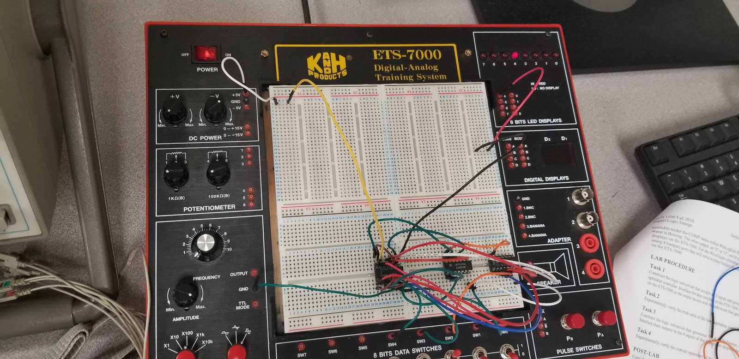

Fig 2.

Fig 2&3 Displaying the overall correctness of the circuit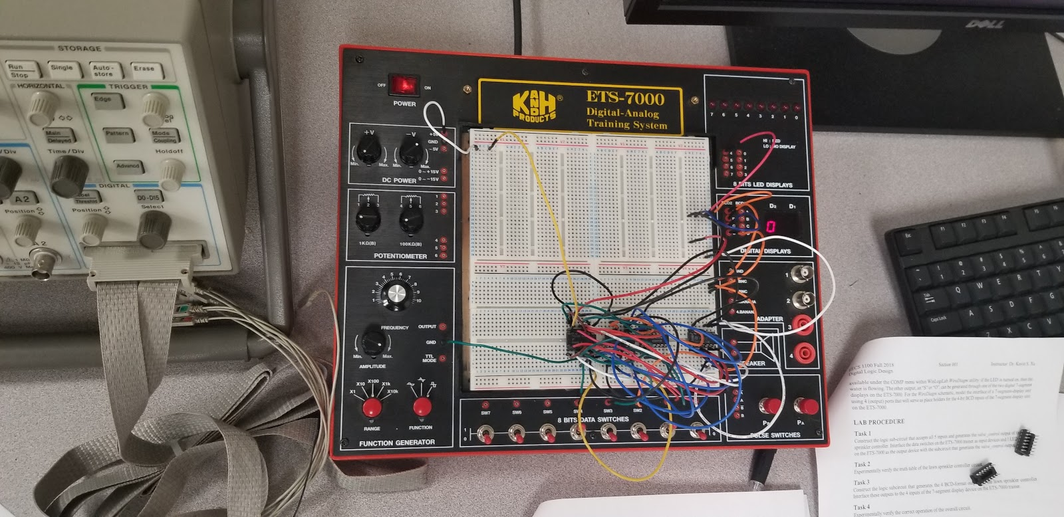

Fig 3

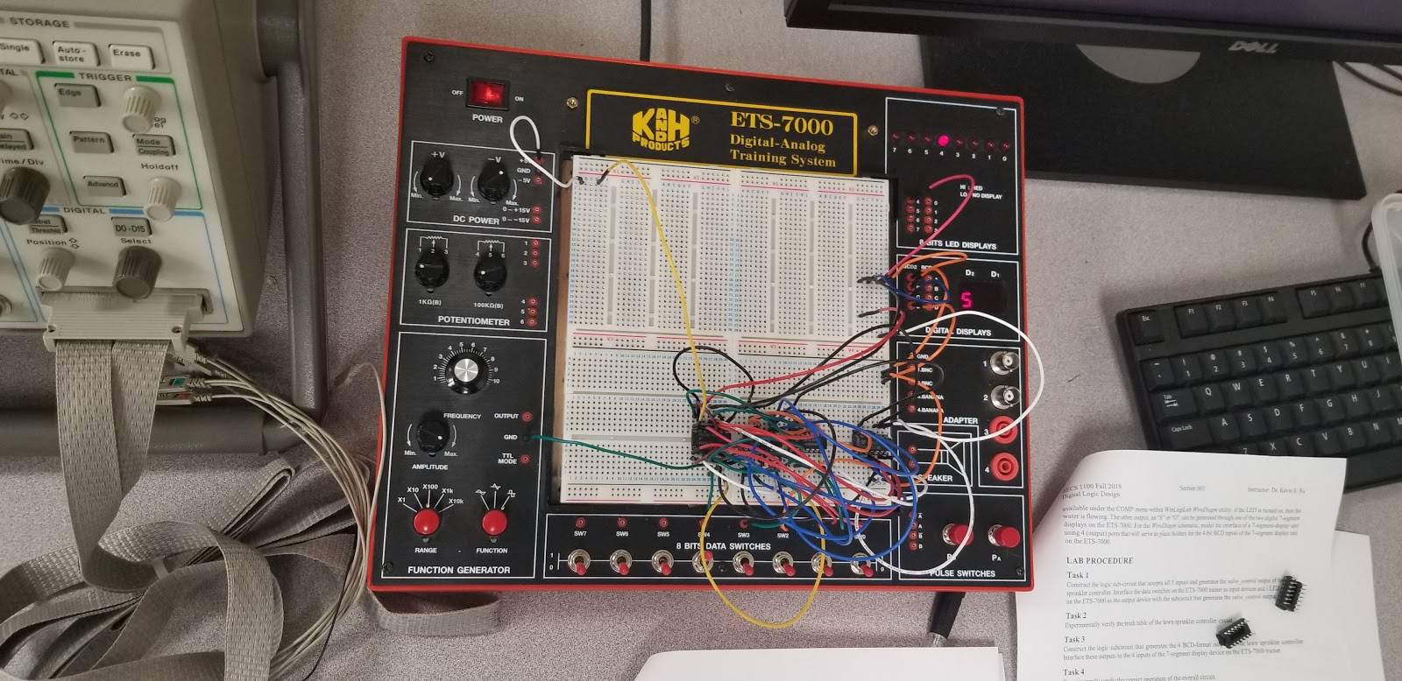

Discussion

In the lab we had minor problems. We started with one group members circuit first and it didn’t work so we tried the other group members circuit, which didn’t work either. Than one member noticed he had one input in the wrong pinhole, we had it in the NC so it wasn’t going through the NAND gate and once we fixed that problem our circuit worked.

Appendix

Lab Attendance:              Bernard Owusu Sefah: Yes        Brandon Kowal: Yes

Involvement in Lab:                  Bernard Owusu Sefah: 45 Brandon Kowal: 55

Involvement in Lab Report:       Bernard Owusu Sefah: 60 Brandon Kowal: 40